Problem - Solution Fit Template
Project: Emotion-Aware Personalized Learning Platform

1. Customer Segment(s)
School students, college students, online learners, and self-learners who study independently without real-time human support.

2. Problem
Learners frequently experience emotions (confusion, frustration, boredom, curiosity) during study sessions that go unnoticed, resulting in disengagement, reduced motivation, and generic, one-size-fits-all learning support.
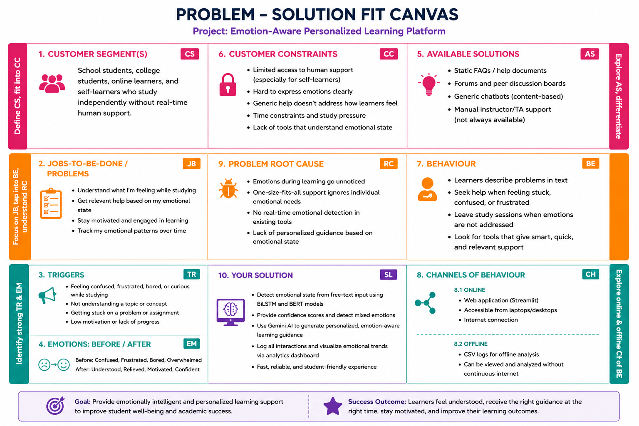

3. Existing Alternatives
- Static FAQs / help documents
- Forums and peer discussion boards
- Generic chatbots that respond to content, not emotional state
- Manual instructor/TA support (not always available, especially for self-learners)

4. Solution
An AI-powered platform that: - Detects a learner’s emotional state directly from free-text input using BiLSTM and BERT models - Calculates confidence scores and detects mixed emotions - Uses Gemini AI to generate personalized, emotion-aware learning guidance - Logs interactions and visualizes emotional trends via an analytics dashboard

5. Key Metrics
- Emotion classification accuracy (BiLSTM vs BERT)
- Confidence score distribution across predictions
- Frequency of mixed-emotion detections
- Number of logged interactions over time
- Turnaround time from input to guidance (performance/latency)

6. Unique Value Proposition
Combines dual deep-learning emotion classifiers (BiLSTM + BERT) with generative AI (Gemini) to deliver personalized, emotionally-aware learning guidance in real time — something static or purely content-based tools cannot do.

7. High-Level Concept
“An emotionally intelligent study companion that reads how a student feels — not just what they type — and responds accordingly.”

8. Early Adopters
Self-learners and online course students who study without direct instructor access and would benefit most from automated emotional check-ins.

9. Existing Solution Gaps Addressed
- No existing lightweight tool combines dual-model emotion detection with generative personalized guidance in an educational context
- Fills the gap between purely academic content tools and emotional/motivational support tools

